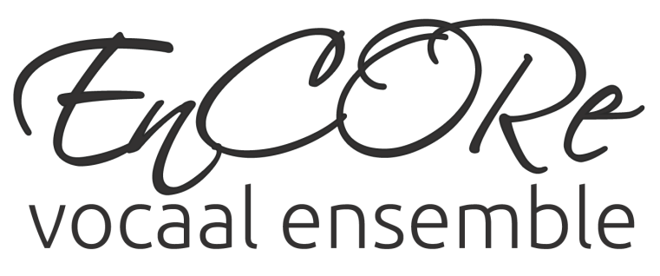
Programma Concert 21 en 23 februari De TopZ

- The Morning Trumpet
- Tourdion
- Je ne l’ose dire
- Swing Low
- Be our Guest

- Ein Hennlein
- Shenando
- King Louie
- The Bare Nessecities

- Contrapunto
- Irish Blessing
- Beauty and the Beast
- Joshua fit the Battle

- Only Time
- Viva la Vida
- Turning Tables
- We all stand together

- Always look on the bright Side

